Text Analytics
It is the automated process of analyzing text to gather insights, patterns and trends. Since, text is unstructured data it is somewhat difficult to analyses it programmatically.

How text gets analyzed
Split the sentence into small elements in the form that they can be treated numerically.

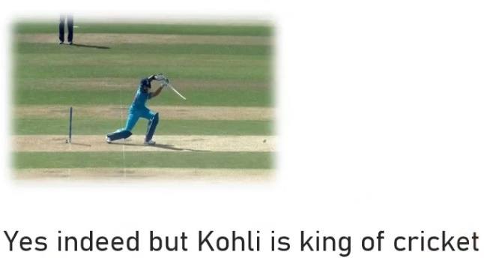



Split Sentence into block of text

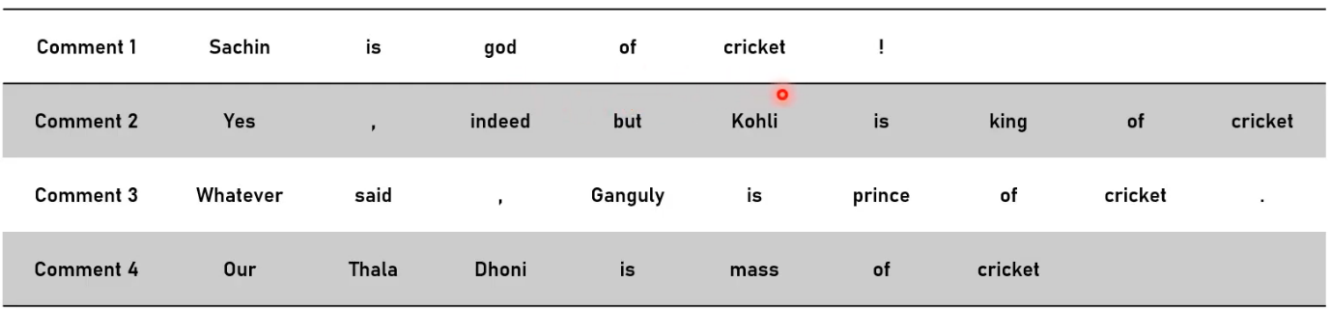
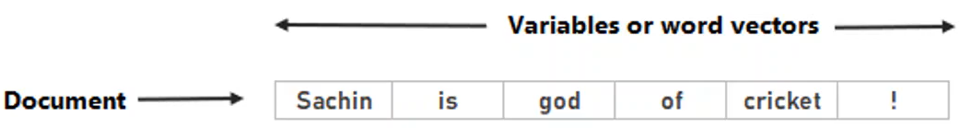

Observations
- Comment 1 is split into 6 columns
- Comment 2 is split into 9 columns
Columns which contain block of words are called as variables or word vector.

Before cleaning text
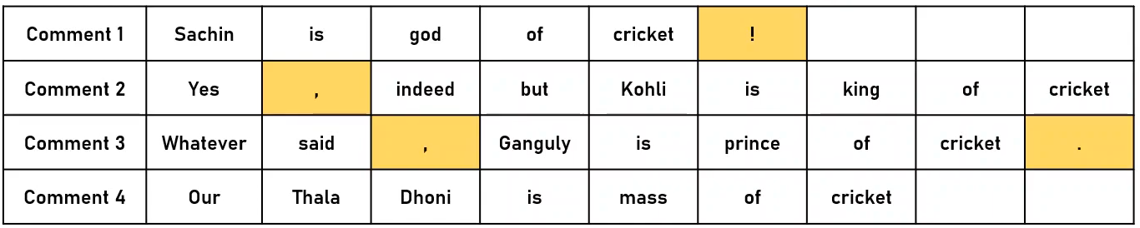
The one highlighted in yellow are special characters
The characters such as comma, punctuations, dot are removed first

After cleaning text
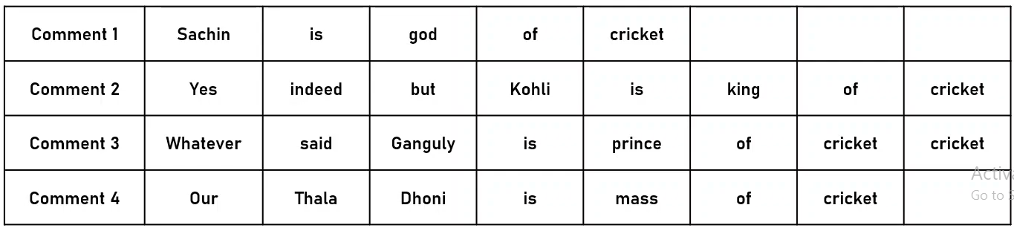
Having text in this type of arrangement is difficult to analyze especially considering here huge number of comments.

To analyze text we introduce something called as term frequency matrix or variable frequency matrix
What we actually do over here is we take all the unique words from the comments and list down it into separate columns.
If it is present in the comment then put it as 1 or else 0.
From this table we can figure out that three words are always spoken in these comments

Let’s highlight two important terms we generally use in text analytics
Token: It is block of words that we see post data cleaning. We already completed process known as tokenization.
Name identity extraction: Process of extracting names from comments is known as Name identity extraction.
We pause on the set of words so that computer can understand that it is name and have a single meaning.

Explain in brief steps in text analysis process
Here's a detailed explanation of each step in the text analysis process, accompanied by examples to illustrate how each one works:
1. Text Preprocessing:
This step is crucial to clean and prepare the text for analysis.
- Tokenization: Example: The sentence "Text analysis is fun!" can be tokenized into ["Text", "analysis", "is", "fun", "!"].
- Lowercasing: Example: Convert "Text Analysis Is Fun" to "text analysis is fun" to ensure uniformity.
- Stopword Removal: Example: From the sentence "Text analysis is fun", remove common words like "is", leaving ["text", "analysis", "fun"].
- Stemming/Lemmatization: Example:
  - Stemming: "running" becomes "run", "better" becomes "better".
  - Lemmatization: "running" becomes "run", "better" becomes "good" (reducing words to their root form based on meaning).
2. Text Representation:
This converts text data into numerical formats so that it can be analyzed by algorithms.
- Bag of Words (BoW): Example: For the sentences "I love dogs" and "I love cats", the BoW model builds a frequency table like:
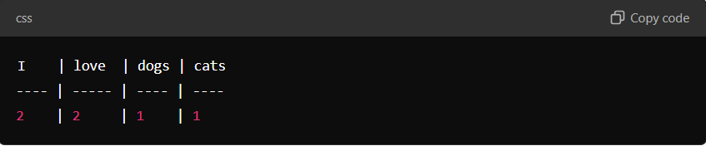
- TF-IDF (Term Frequency-Inverse Document Frequency): Example: For the word "analysis" that appears frequently in one document but rarely in others, TF-IDF will assign it a higher weight compared to common words like "is" or "the".
- Word Embeddings: Example: Word2Vec or GloVe representations of words as vectors. The words "king" and "queen" would be closer in vector space than "king" and "table", capturing the semantic meaning.
3. Feature Extraction:
Extract features from the text to serve as input for machine learning models.
- Word Frequency and N-grams: Example: In the sentence "Data science is great", you can count word occurrences or generate bigrams like ["Data science", "science is", "is great"] to capture word sequences.
- Part of Speech (POS) Tagging: Example: In the sentence "The cat sits", POS tagging will label "The" as a determiner, "cat" as a noun, and "sits" as a verb.
4. Sentiment Analysis:
Determining the sentiment of the text.
- Example: For the sentence "I love this product", sentiment analysis might classify it as positive. For "I hate this product", it would be classified as negative.
- Rule-Based Models: Manually define rules like assigning sentiment to words (e.g., "love" is positive, "hate" is negative).
- Machine Learning Models: Train models to learn sentiment from labeled examples.
5. Topic Modeling:
Identifying the underlying topics within a document collection.
- Latent Dirichlet Allocation (LDA): Example: Given a set of documents, LDA might identify topics like "technology", "health", "politics", etc. Each document will have a distribution of topics (e.g., 60% technology, 40% health).
6. Named Entity Recognition (NER):
Identify and classify entities in text into categories like names of people, places, or organizations.
- Example: In the sentence "Barack Obama was born in Hawaii", NER will recognize "Barack Obama" as a Person and "Hawaii" as a Location.
7. Text Classification:
Categorize text into predefined categories using machine learning models.
- Example: Classify emails as Spam or Not Spam using models like Naive Bayes or Support Vector Machines (SVM).
- Naive Bayes: Uses the probability of words occurring in certain classes to make a prediction.
- Support Vector Machines (SVM): Finds the optimal boundary that separates text into categories (e.g., spam vs. non-spam).
8. Text Summarization:
Extracting the most important information from the text to create a summary.
- Example: For a lengthy news article, text summarization can provide a concise summary by extracting key sentences.
- Extractive Summarization: Selects key sentences from the text to form a summary.
- Abstractive Summarization: Generates new sentences based on understanding the content (more like how a human might summarize).
9. Clustering:
Grouping similar text documents together.
- K-Means Clustering: Example: Group product reviews into clusters where one cluster represents positive feedback and another represents negative feedback without any predefined labels.
10. Evaluation:
Assess the quality of models used for tasks like classification or clustering.
- Example: For a text classification model, you may evaluate it using:
  - Precision: How many predicted positives were actually positive.
  - Recall: How many actual positives were correctly predicted.
  - F1-Score: Harmonic mean of precision and recall to get a balanced performance measure.
For clustering, you might use metrics like Silhouette Score to measure how well the data points are assigned to clusters.

Outline of slides in Text Analytics
1. Introduction to Text Analytics
- Definition: Text analytics involves converting unstructured text data into meaningful insights using computational and statistical methods. It is widely used in applications like sentiment analysis, spam detection, and document categorization.
- Need for Text Analytics: Handling vast amounts of unstructured data and extracting useful information.
- Applications: Sentiment analysis, topic classification, spam filtering, recommendation systems, and more.
2. Text Classification
- Definition: Text classification is the process of assigning predefined categories or labels to a given text document.
- Types of Text Classification:
  - Binary classification: Classifying text into two categories (e.g., spam vs. not spam).
Example: Spam Detection. Imagine you have an inbox where incoming emails are sorted into two categories: “Spam” and “Not Spam.” The system analyzes the content of each email and classifies it accordingly.
Use Case: Email Filtering - A binary classifier is used to filter emails into "Spam" or "Not Spam" categories, helping users manage their inbox efficiently.
Illustration:
- Visualize a set of emails where one is tagged "Spam" and another is tagged "Not Spam." The classifier makes this binary decision for each new email.

  - Multiclass classification: Classifying text into more than two categories (e.g., categorizing news articles into politics, sports, technology, etc.).
Example: News Categorization. Suppose you run a news website and have categories like "Politics," "Sports," "Technology," etc. Every time a new article is published, the system classifies it into one of these categories.
Use Case: Document Categorization - Organizing documents or articles into various categories such as business, entertainment, and health.
Illustration:
- Imagine a news website with a feed where articles are tagged into separate categories (e.g., one article is labeled "Politics," another "Sports," and a third "Technology"). Each article belongs to only one category.
  - Multilabel classification: Assigning multiple labels to a document (e.g., a product review tagged as both "electronics" and "gadgets").
Example: Product Review Tagging. Consider an online store where a product review might be tagged with both "Electronics" and "Gadgets." In this case, one review gets multiple labels because it falls into several categories.
Use Case: Multilabel Product Categorization - Classifying product reviews or descriptions into multiple categories like “Home Appliances,” “Electronics,” and “Discounted.”
Illustration:
- Picture a product review where the text is tagged with two or more labels, such as "Electronics" and "Gadgets." This demonstrates that a document can fit into multiple categories.

- Common Use Cases: Email filtering, document categorization, sentiment analysis.
3. Text Preprocessing
- Tokenization: Breaking down text into individual words or tokens.
- Stopword Removal: Eliminating common words that do not add significant meaning (e.g., "and", "the", "in").
- Stemming and Lemmatization: Reducing words to their base or root form (e.g., "running" becomes "run").
- Lowercasing: Converting all text to lowercase for uniformity.
- Removing Special Characters: Stripping out unnecessary punctuation, symbols, or numbers.
- Term Frequency (TF) and Inverse Document Frequency (IDF): A weighting scheme that reflects how important a word is to a document in a corpus.
4. Feature Extraction Techniques
- Bag of Words (BoW): Representing text as a set of words, disregarding grammar and word order, but keeping multiplicity.
- TF-IDF: A refinement of Bag of Words that adjusts for word frequency and rarity.
- Word Embeddings: Representing words in continuous vector spaces (e.g., Word2Vec, GloVe) to capture semantic meanings.
- N-grams: Extracting sequences of N words from the text to capture word relationships (e.g., bigrams, trigrams).
- Document Embeddings: Representing entire documents as vectors (e.g., Doc2Vec).
5. Text Classification Algorithms
- Naive Bayes Classifier: Assumes independence between words and uses Bayesian probability to classify text.
- Support Vector Machines (SVM): Finds the best boundary (hyperplane) to separate classes.
- Logistic Regression: A statistical model that predicts the probability of class labels.
- Decision Trees: Builds a tree-like structure where each node represents a decision based on features.
- Random Forests: An ensemble technique combining multiple decision trees for better performance.
- Deep Learning Methods:
  - Recurrent Neural Networks (RNNs): Suitable for sequential data, such as text, capturing dependencies between words.
  - Convolutional Neural Networks (CNNs): Initially designed for images but effective in capturing n-gram features in text.
  - Transformers (e.g., BERT, GPT): Modern techniques based on attention mechanisms, offering state-of-the-art performance in text classification tasks.
6. Evaluation Metrics for Text Classification
- Accuracy: Proportion of correctly classified documents.
- Precision: Measure of how many selected items are relevant.
- Recall: Measure of how many relevant items are selected.
- F1-Score: Harmonic mean of precision and recall.
- Confusion Matrix: Table showing true positives, true negatives, false positives, and false negatives.
- ROC Curve and AUC: Graphical representation and metric to evaluate classifier performance across different thresholds.
7. Challenges in Text Analytics
- Data Sparsity: The occurrence of many unique words, leading to sparse representations.
- Synonymy and Polysemy: Different words having the same meaning (synonymy) or one word having multiple meanings (polysemy).
- Context Sensitivity: Meaning of words can change depending on the context (e.g., sarcasm detection).
- Class Imbalance: Some categories may have significantly more data than others.
8. Advanced Techniques in Text Classification
- Transfer Learning: Using pre-trained models (e.g., BERT) for specific text classification tasks.
- Topic Modeling: Algorithms like Latent Dirichlet Allocation (LDA) that help in discovering topics within text data.
- Hybrid Models: Combining different methods (e.g., rule-based and machine learning models) for better accuracy.
9. Tools for Text Analytics
- Python Libraries:
  - NLTK: Natural Language Toolkit for preprocessing and basic text analysis.
  - spaCy: Industrial-strength NLP library for complex tasks.
  - scikit-learn: For implementing machine learning algorithms.
  - TensorFlow/Keras and PyTorch: For deep learning-based text classification models.
10. Real-World Case Studies
- Spam Detection: Identifying whether an email is spam or not using text classification.
- Sentiment Analysis: Classifying customer reviews or social media comments into positive, negative, or neutral.
- Topic Classification: Automatically categorizing news articles into relevant sections like politics, technology, or sports.

